**Figures**

**Figure 1:** Map of the study region highlighting the selected areas of interest (AOI) in orange within each Oblast. An “oblast” in Ukraine is the main type of first-level administrative division, equivalent in hierarchy, though not in absolute size, to states in the US context. The gray-dashed area depicts the occupied territories of Crimea and Sevastopol, both excluded from the current study.

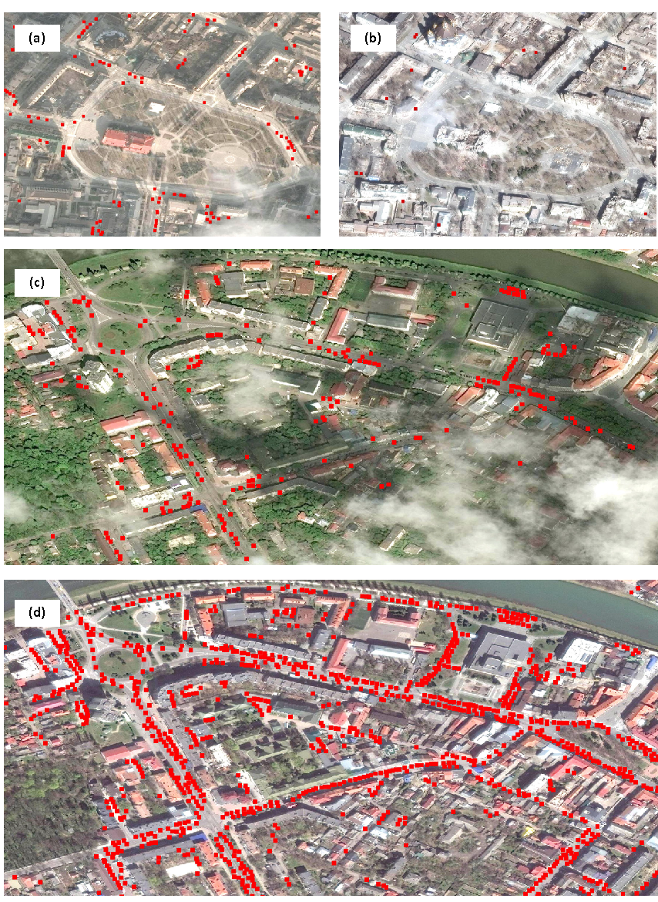

**Figure 2:** Satellite images showing the effect of war on the number of cars circulatingin two distinct Ukrainian cities before and during the war. Panels (a) and (b) depict a snapshot of Mariupol before (12.02.2021) and during (29.03.2022) the war, respectively, highlighting the region around the Donetsk Academic Regional Drama Theatre that was heavily bombarded on 16th March. Panels (c) and (d) show close-up shots of the area around the Transcarpathian Regional Clinical Hospital of A. Novak before (30.04.2019) and during (14.04.2022) the war, respectively, located in the city of Uzhhorod. While Mariupol presented a massive drop in the number of cars in the first month following the start of the War, Uzhhorod depicted the opposite trend. Satellite images © 2019–2023 Maxar Technologies.

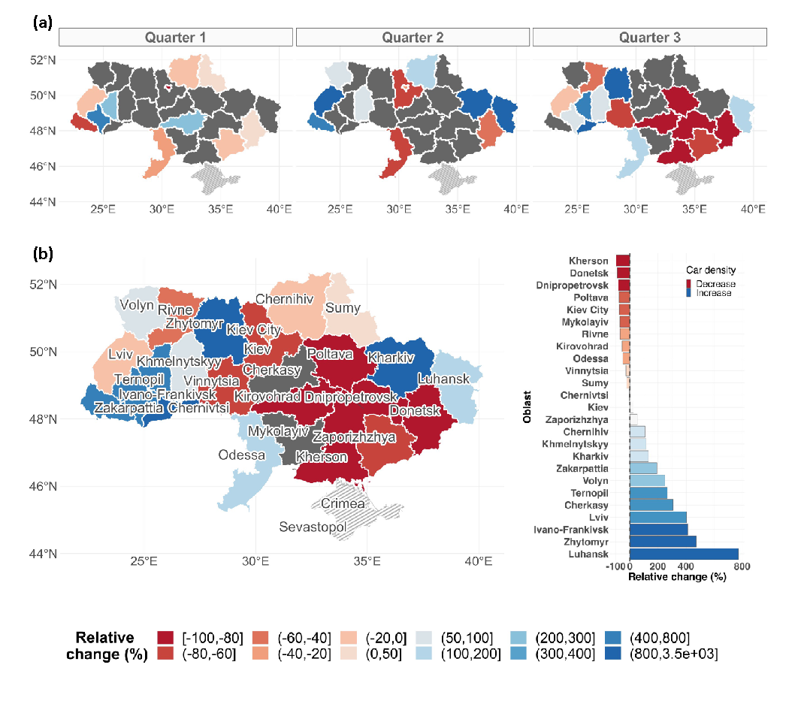**Figure 3:** Change in average car density for all Ukrainian primary administrative units (Oblasts) during the first year of war (2022). Values reflect the percentage change in average car density after the start of the war (24 February) relative to the baseline (2019) for either quarterly (a) or yearly (b) temporal resolution. Oblasts colored in dark gray represent cases in which the relative change could not be calculated due to missing data for either or both years. The occupied territories of Crimea and Sevastopol were not considered in the current study (dashed areas).

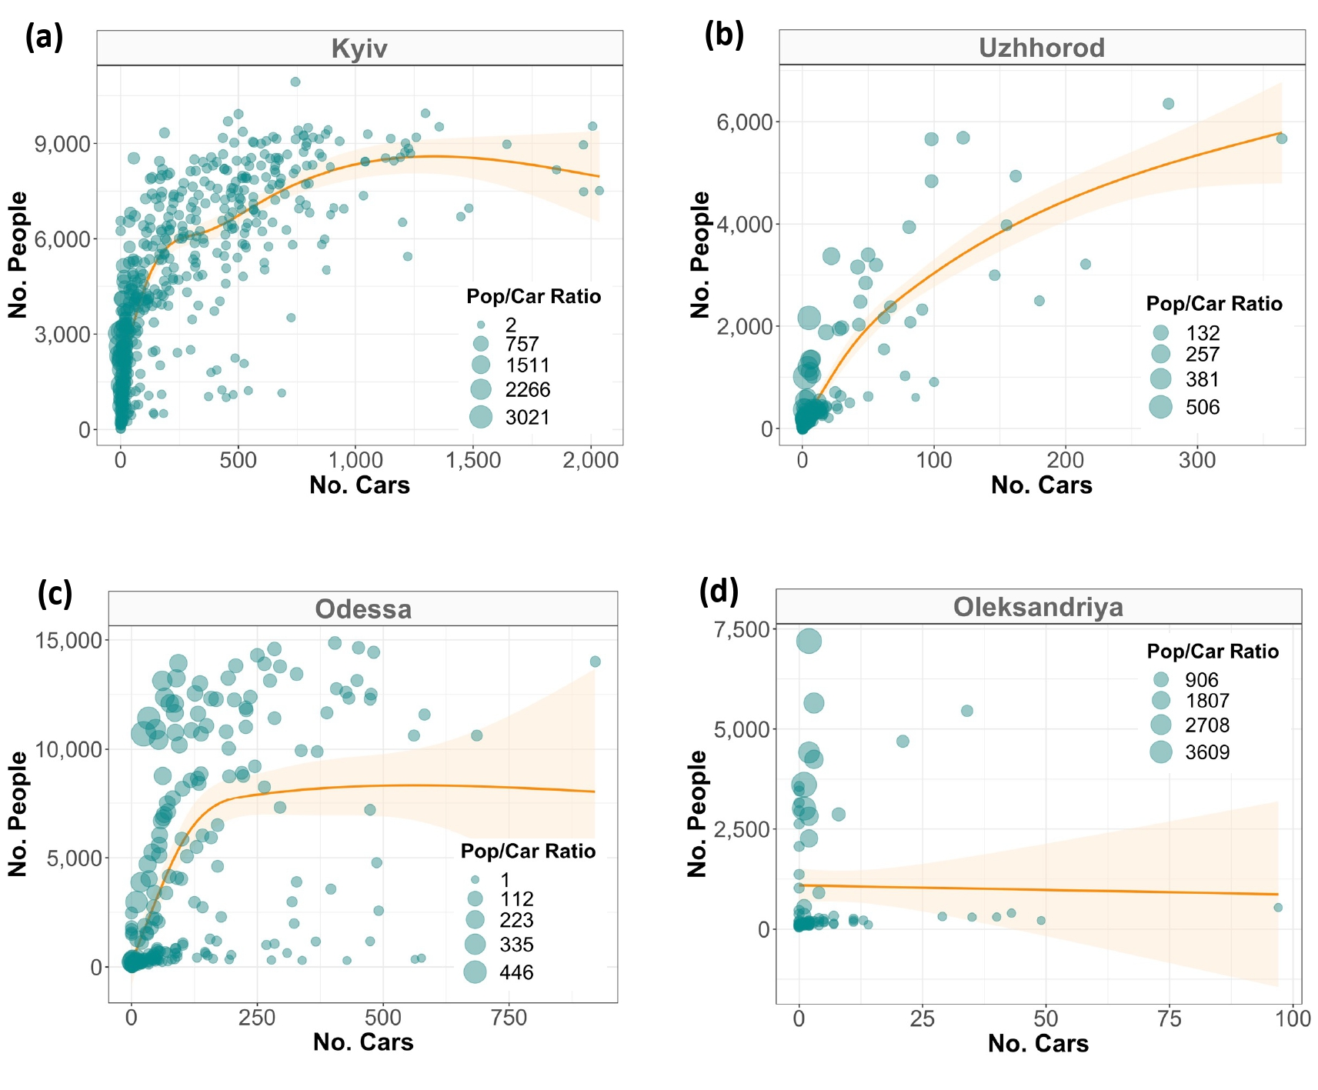**Figure 4:** Relationship between the (gridded) average number of people and cars for four selected cities during the baseline year (2019). For most cities, the relationship is positive and non-linear akin to Kiev (a). Occasionally, the relationship is linear as for Uzhhorod (b), and rarely there is no (clear) relationship as in Odessa (c) or Oleksandriya (d). The orange smoothed function highlights the trend line from the GAM model bounded by its 95% confidence interval, with circle sizes scaled by the population/car ratio. Each data point assembles information from a unique grid cell (1 x 1 km) within the given city. For a complete overview, refer to Figs. S3-S7 in the Supplementary Material.

**Figure 5:** Predictions of internally displaced people across three different cities (left panels). The orange line marks the pre-War population size (2019), from which relative change has been derived for the applicable months in either 2020 (first COVID-19 year, gray bars) or 2022 (War year, turquoise bars). Numbers on top of each bar denote the relative population change (in %), with colors reflecting either an increase (blue) or decrease (red). Dashed and plain bars distinguish the two tested prediction methods: linear ratio (dashed) and Generalized Additive Model (GAM, plain). Right panels depict the percentage of area covered by the satellite images underlying a given month relative to the city’s area of interest (AOI). Note that the larger population drops/increases for some cities and months should be interpreted with additional care, as it could be an artifact induced by the smaller spatial extent that is reflected by the underlying satellite images. The models for Uzhhorod, for example, predicted a population increase of up to 23% in April 2022 (left panels). This number is nevertheless likely underestimated, as the collection of satellite imagery for the given month covered less than 50% of the city’s extent (right panels). For the full set of results, refer to Figs. S8S-S12 in the Supplementary Material.

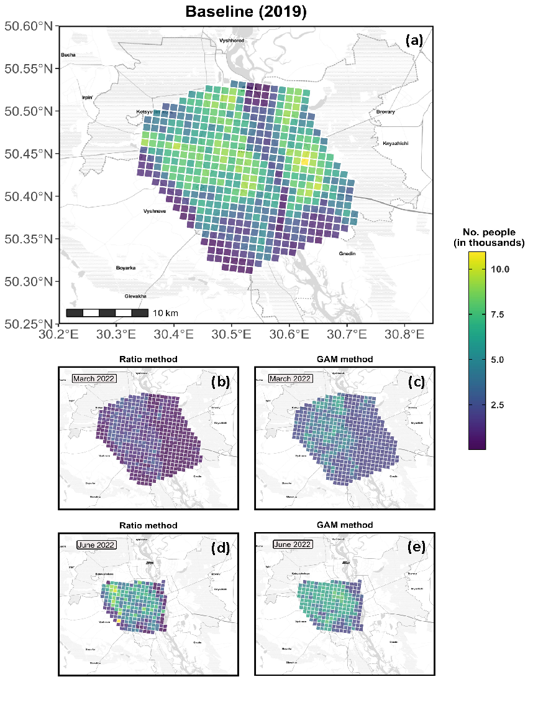

**Figure 6:** Gridded population for Kiev city, with each grid cell measuring 1 x 1 km. The baseline population (a) was retrieved from WorldPop’s database, whereas the population for March and June 2022 were predicted through either the Ratio (b and d) or the GAM method (c and e). Note that the satellite images underlying the month of June 2022 covered only a fraction of the city’s AOI (a), which is also denoted in the right panels in Fig. 5. To interpret the present figure in relative terms, refer to Supplementary Fig. S14.

**Figure 7:** Car density expressed as a function of (a) image resolution, (b) presence of snow, (c) off-Nadir angle, (d) sun elevation angle, and (e) percentage of cloud coverage.